Assignment 2- Case Study

Stage 3 Lab Activities

SmartCare Domain Modelling
AI OFF -> AI ON -> COMPARE -> VERIFY | 1 hour

A - Requirements Review
Highlight nouns, verbs and business rules in SmartCare v0.2.
Category | Items identified in SmartCare v0.2
Nouns (candidate objects) | patient, practitioner, appointment, appointment record, patient record, availability / time slot, status, operational report, staff/administrative user, system access/permission.
Verbs (candidate behaviours) | add, delete, search, update (records); book, cancel, reschedule (appointments); view (history/records); generate (reports); check (for conflicts/overlap); confirm (booking); notify (of errors).
Business rules | FR-03/FR-09: two appointments cannot occupy the same practitioner and timeslot. An error is shown if attempted. FR-13: a practitioner's own availability slots must not overlap when updated. FR-08: only authorised staff/practitioners may view or change patient records as they can’t patients cannot self-edit. FR-10: a successful booking must show a confirmation message.

B - Candidate Classes
Record candidate concepts, supporting requirements, state and behaviour.
Candidate | Requirement(s) | State | Behaviour
Patient | FR-01, FR-07, FR-11 | patientID, name, contactNumber, dateOfBirth, status | createRecord(), updateRecord(), archiveRecord(), viewAppointmentHistory()
Practitioner | FR-04, FR-06, FR-13 | practitionerID, name, specialty | updateAvailability(), viewSchedule(), viewPatientRecord()
Appointment | FR-02, FR-03, FR-05, FR-07, FR-09, FR-10 | appointmentID, date, time, status | book(), reschedule(), cancel(), checkConflict()
Availability (optional class) | FR-04, FR-13 | availabilityID, dayOrDate, startTime, endTime | addSlot(), updateSlot(), checkOverlap(), isWithinSlot()
Clinic (excluded) | none | n/a | No requirement manages more than one clinic location; this is context, not a system object.
Database / Report (excluded) | FR-12 (report only) | n/a | "Database" is an implementation concept, not a domain concept.

C - CRC Cards
Create CRC cards for Patient, Practitioner and Appointment.

Patient
Responsibilities | Collaborators
Store own personal & contact details (name, DOB, contact number) | —
Request a new appointment booking or cancellation | Appointment
View own appointment history (read-only) | Appointment

Practitioner
Responsibilities | Collaborators
Maintain own availability (add/update time slots) | Availability
View own appointment schedule | Appointment
View patient records & history for assigned patients | Patient, Appointment

Appointment
Responsibilities | Collaborators
Record date, time, status and linked patient/practitioner | Patient, Practitioner
Check for a conflicting booking before confirming | Availability
Support rescheduling and cancellation (status transitions) | —

D - UML Model
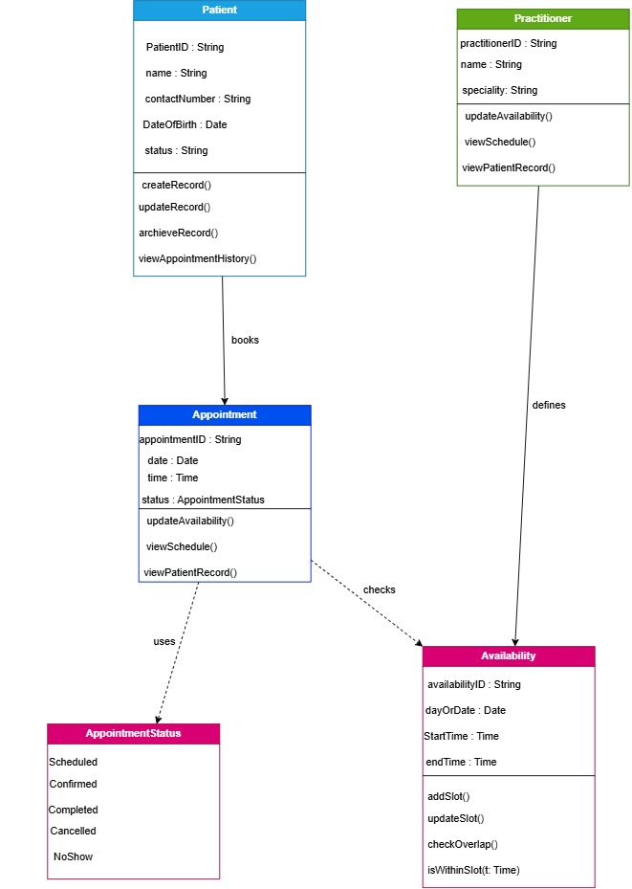

E - AI Design Review
Ask AI to suggest classes and relationships using only confirmed requirements; require supporting requirement IDs.
AI OFF (manual pass). Before asking AI, the manual review of SmartCare v0.2 in Sections A–C identified four classes with independent identity and behaviour: Patient, Practitioner, Appointment, and Availability. Name, Status and Clinic were set aside as an attribute, an attribute/enumeration, and out-of-scope context respectively.
AI ON (prompt used). Using only the confirmed requirements in SmartCare v0.2 (FR-01 to FR-13), suggest candidate domain classes and relationships. For every class or relationship, you propose, tell the specific requirement ID that justify it. Do not propose classes that aren't supported by a requirement.”
AI suggestions received. The AI response confirmed Patient, Practitioner, Appointment and Availability with the same requirement IDs already found manually by me It also proposed six additional classes not identified manually: PatientManager, PractitionerManager, AppointmentManager, ClinicController, NotificationManager, and ScheduleEngine and none of which the AI could tie to a specific requirement ID when asked to just them.

F - Compare and Decide
Record at least one accepted, modified and rejected AI suggestion.
AI suggestion | Decision | Requirement evidence | Reason
Availability class to hold a practitioner's slots separately from Practitioner | Accepted | FR-04, FR-13 | Both requirements describe operations (add/update a slot, check for overlap)
ScheduleEngine to run conflict/overlap checks | Modified (merged) | FR-03, FR-09, FR-13 | There is underlying need, but it duplicates responsibility already given to Appointment.checkConflict() and Availability.checkOverlap(). Kept the behaviour on those two classes instead of adding a third.
PatientManager / PractitionerManager / AppointmentManager ‘god classes’ | Rejected | None cited | When asked to justify these with a requirement ID, the AI could not. They are an implementation/design pattern (centralised managers), not business concepts, and they duplicate responsibilities already assigned to the domain classes themselves.
NotificationManager (email/SMS reminders) | Rejected (for v1) | None cited | No functional requirement in v0.2 asks for reminders or notifications. This is an unconfirmed assumption.

G - Python Skeletons

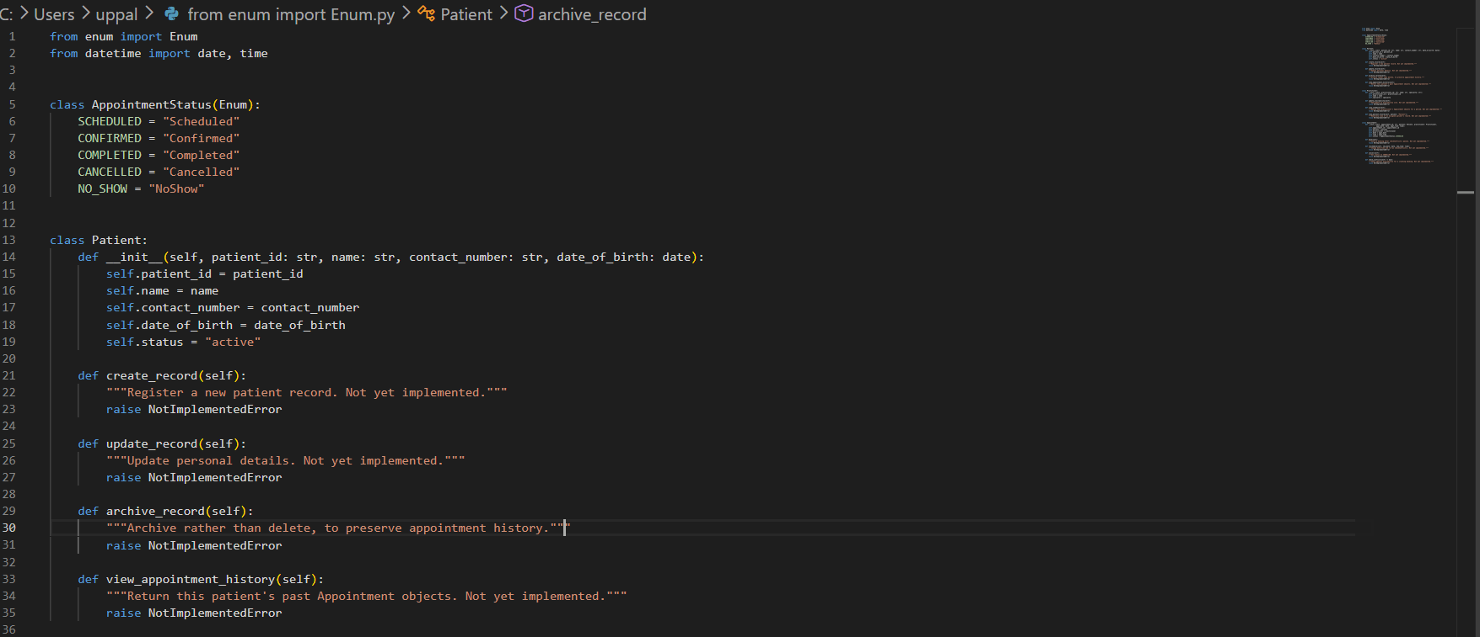
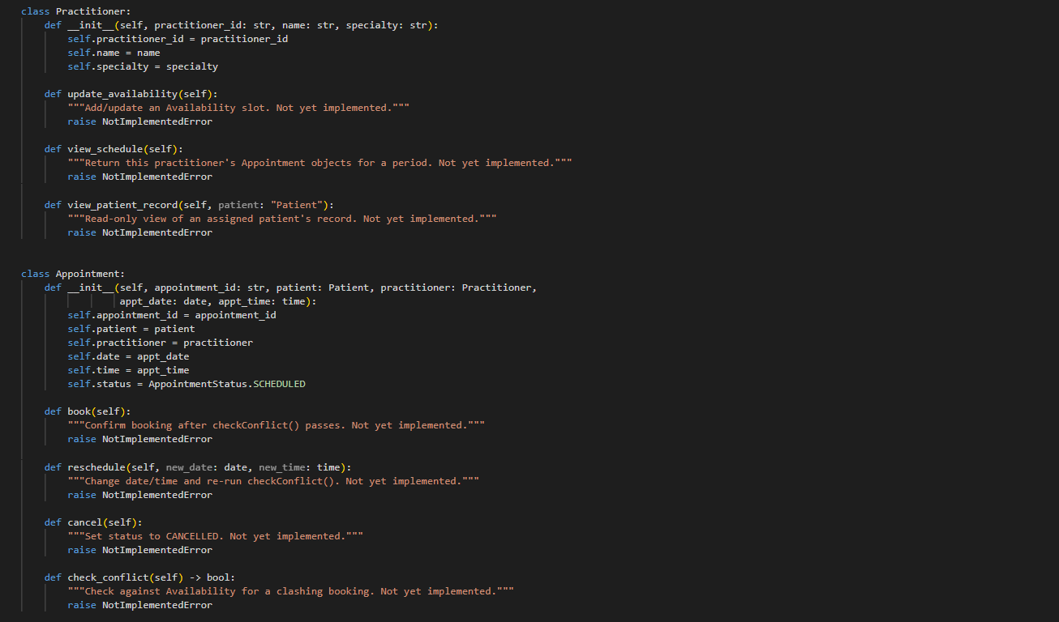

H - Consistency Check

Class | In UML but missing from code? | In code but missing from UML? | Verdict
Patient | None | None | Consistent as all 5 attributes and 4 operations from the diagram are present as stub methods.
Practitioner | None | None | Consistent as the attributes and 3 operations match; viewPatientRecord() takes a Patient parameter as implied by its collaborator link on the CRC card.
Appointment | None | status is typed with a real AppointmentStatus enum, not a plain string | Consistent, and slightly stronger than the diagram
Availability | Not yet coded | n/a | Left out of the code since Section G's instructions named only Patient, Practitioner and Appointment

Reflection
What modelling decision was hardest? Where did AI over-design? What evidence supported your final choices?
Hardest modelling decision. Deciding where Availability's conflict-checking logic should be. Is it on Appointment (checkConflict()) or on Availability (checkOverlap()). The two are easy to confuse because they both prevent double booking. The way I coded it is: checkConflict() is triggered by a new/changed Appointment and asks “does this clash with an existing booking?”, while checkOverlap() is triggered by a Practitioner editing their own hours and asks “do my new slots clash with each other?” These are different triggers and hence different classes.
Where AI over-designed. The AI's first pass proposed Manager/Controller classes (PatientManager, PractitionerManager, AppointmentManager, ClinicController) and a NotificationManager, none of which trace to a requirement. This is a common AI failure as reaching for familiar software-architecture patterns (a manager per entity, a controller per feature) rather than staying inside the business domain described in the case study.
Evidence behind the final choices. Every class and relationship kept in the final model (Patient, Practitioner, Appointment, Availability) traces to at least one functional requirement in the Requirement-to-Concept Trace (Section B), and every AI suggestion that could not be tied to a requirement ID was rejected or merged into an existing class (Section F). The Section H consistency check then confirmed the Python skeletons didn't quietly introduce anything the UML diagram didn't already justify.

